Name: Nilanjan Ghosh

College: SRM Institute of Science and Technology

Course: Java FSE Digital Nurture

Week 1
Exercise 1: Mocking and Stubbing Using Mockito
Aim
To understand and implement mocking and stubbing using Mockito for testing services that depend on external APIs.

Objective
The objective of this exercise is to isolate the service layer from external dependencies by creating mock objects and stubbing predefined responses during unit testing.

Software Requirements
- Java Development Kit (JDK)
- Apache Maven
- Visual Studio Code
- JUnit
- Mockito

Theory
Mockito is a Java framework used for creating mock objects during unit testing. Mock objects simulate the behavior of real objects and help isolate the component being tested.
Mocking
Mocking refers to creating a fake implementation of a dependency.
Example:
ExternalApi mockApi = mock(ExternalApi.class);
Stubbing
Stubbing defines the behavior of a mocked method.
Example:
when(mockApi.getData()).thenReturn("Mock Data");

Procedure
Step 1: Add Mockito Dependency
The Mockito dependency was added to the Maven project through the pom.xml file.
Screenshot 1:
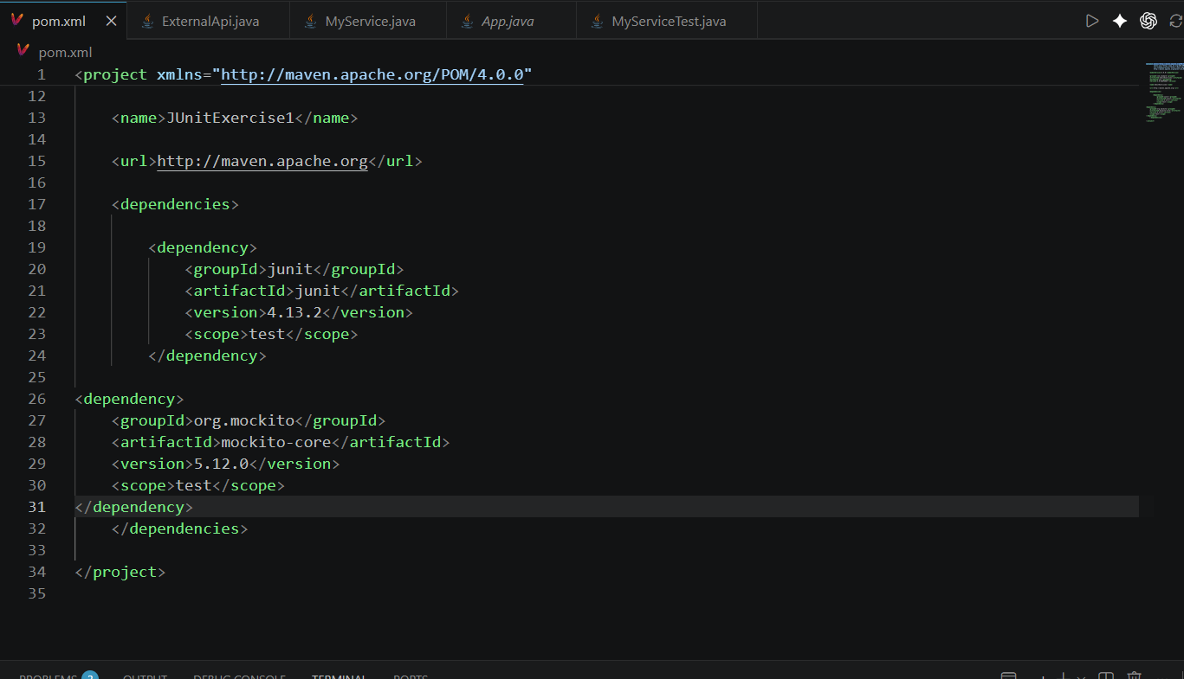

Step 2: Create External API Interface
An interface named ExternalApi was created to represent an external service dependency.
Screenshot 2:

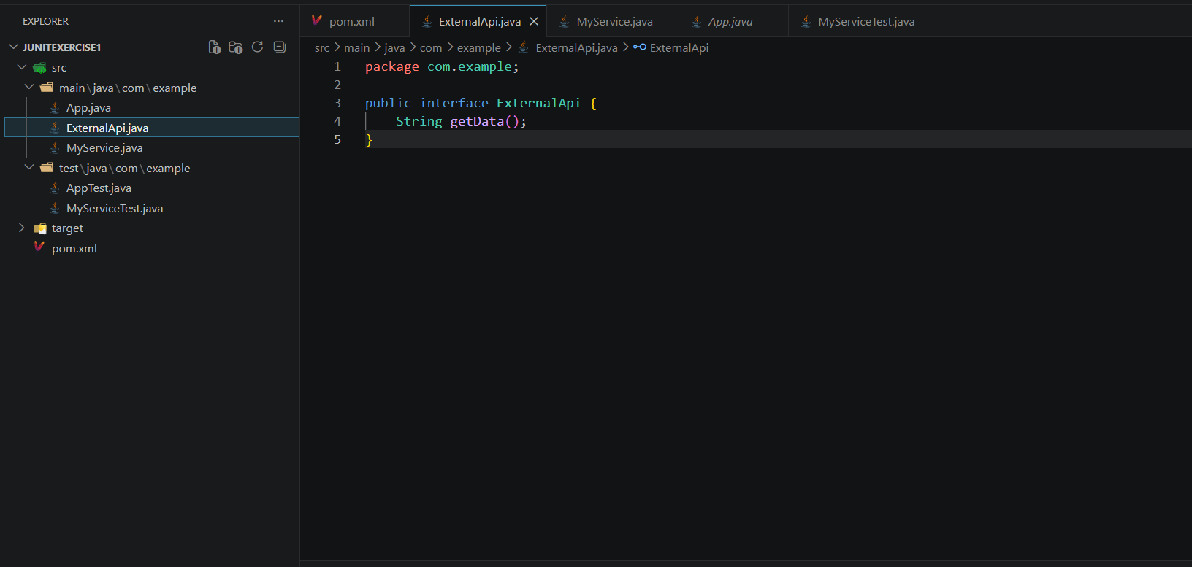

Step 3: Create Service Class
A service class named MyService was created. The service depends on the ExternalApi interface and retrieves data through it.
Screenshot 3:
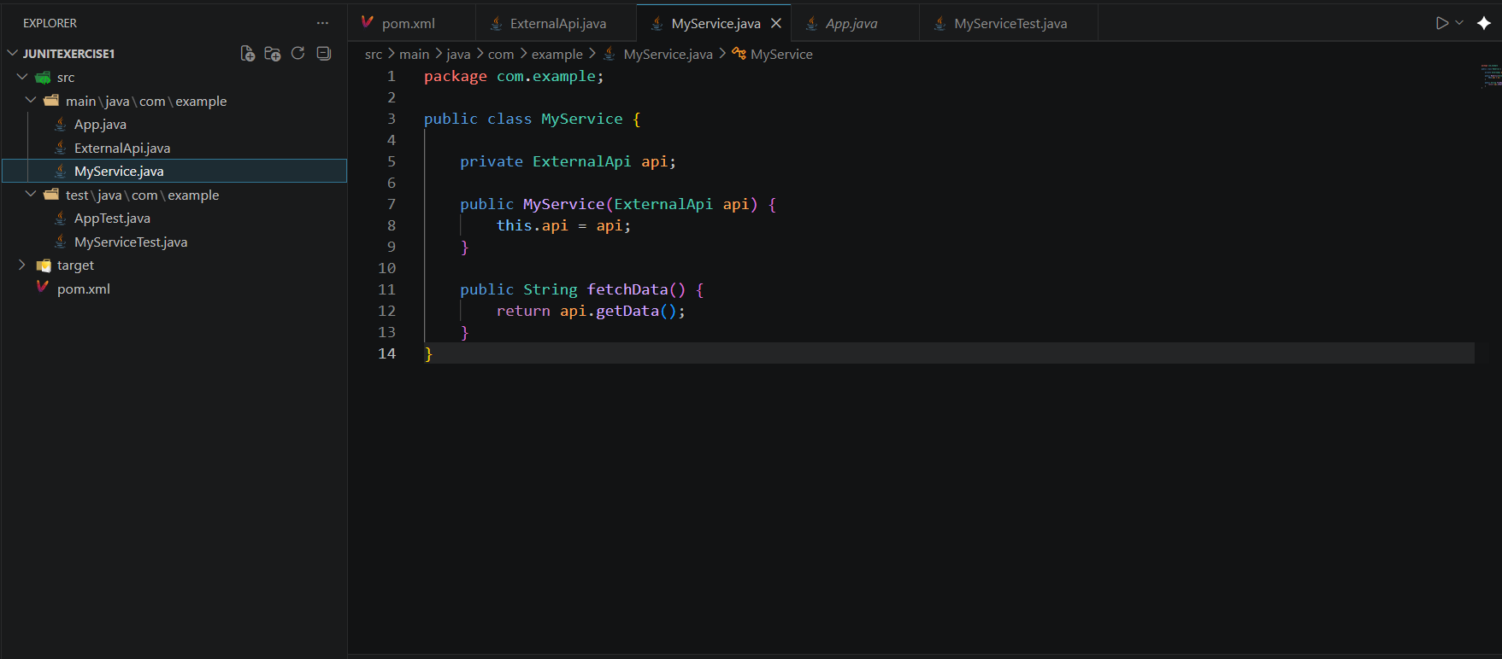

Step 4: Create Test Class
A JUnit test class named MyServiceTest was created.
The test performs the following:
- Creates a mock object.
- Stubs the getData() method.
- Injects the mock object into MyService.
- Verifies the returned result using assertions.
Screenshot 4:
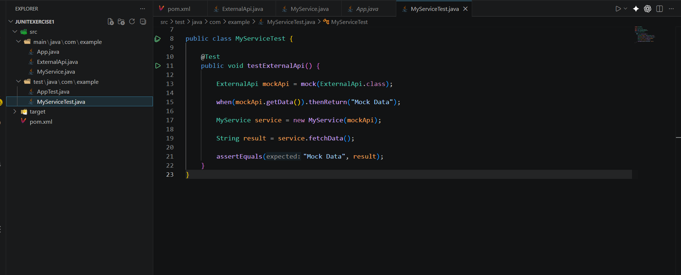

Step 5: Execute Test Cases
The Maven test command was executed.
mvn test
Screenshot 5:
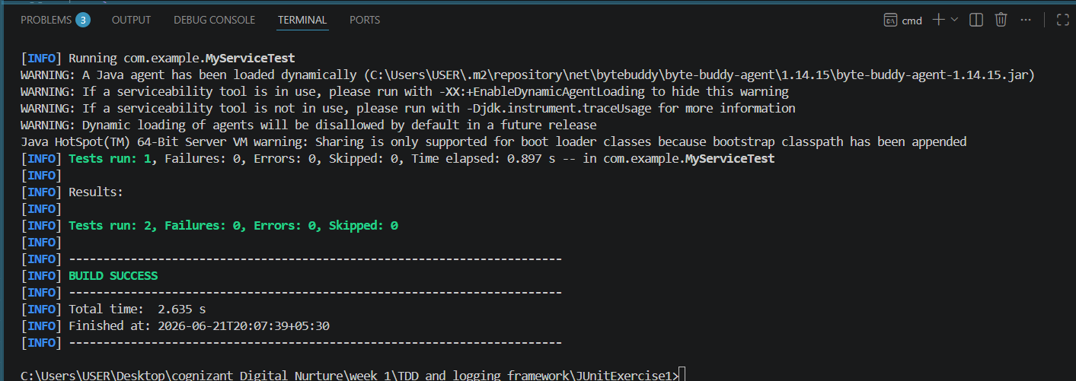

Output
The mocked API returned the predefined value "Mock Data" and the assertion passed successfully.
Output:
Tests run: 1
Failures: 0
Errors: 0

BUILD SUCCESS
Screenshot 6:


Result
Mockito was successfully used to create mock objects and stub method responses. The service was tested independently without requiring a real external API.

Conclusion
This exercise demonstrated the use of Mockito for mocking and stubbing external dependencies. By isolating the service layer from external APIs, unit tests become faster, more reliable, and easier to maintain.

Exercise 2: Verifying Interactions Using Mockito
Aim
To verify that a method is invoked with the expected interaction using Mockito.

Objective
The objective of this exercise is to use Mockito's verification feature to ensure that a dependent object's method is called during execution.

Software Requirements
- Java Development Kit (JDK)
- Apache Maven
- Visual Studio Code
- JUnit
- Mockito

Theory
Mockito provides the verify() method to confirm that a particular method was called on a mock object.
Verification helps ensure that the application interacts correctly with its dependencies.
Example:
verify(mockApi).getData();
This statement confirms that the getData() method was invoked on the mocked API object.

Procedure
Step 1: Create a Mock Object
A mock implementation of the ExternalApi interface was created using Mockito.
Screenshot 1:

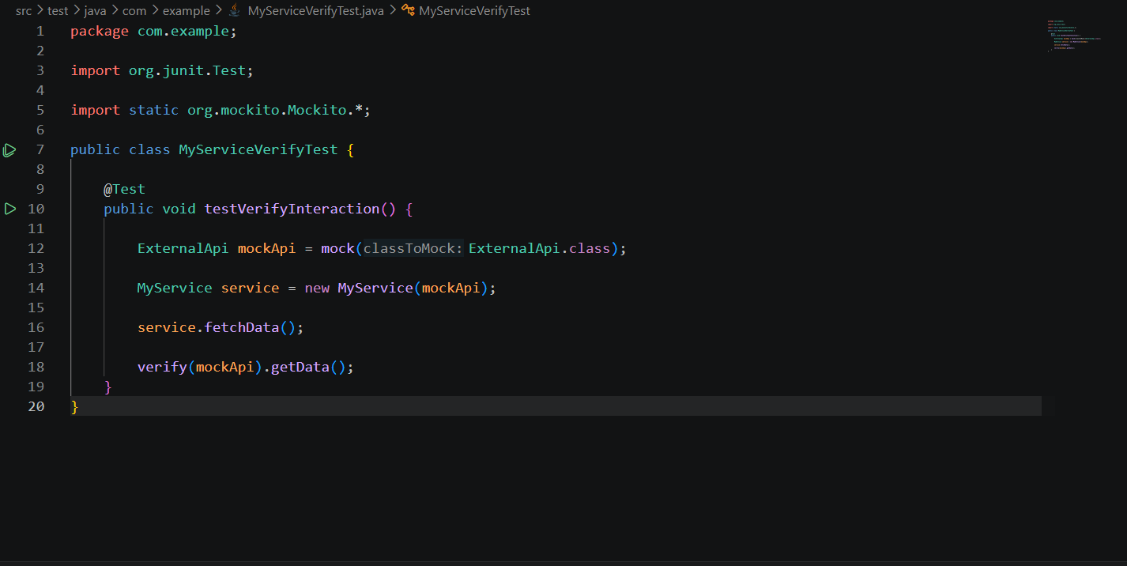

Step 2: Create Service Object
An instance of MyService was created by injecting the mocked API object.
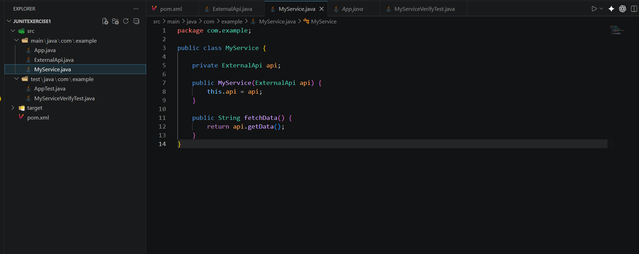
Screenshot 2:

Step 3: Invoke Method
The fetchData() method was called from the service class.
Screenshot 3:

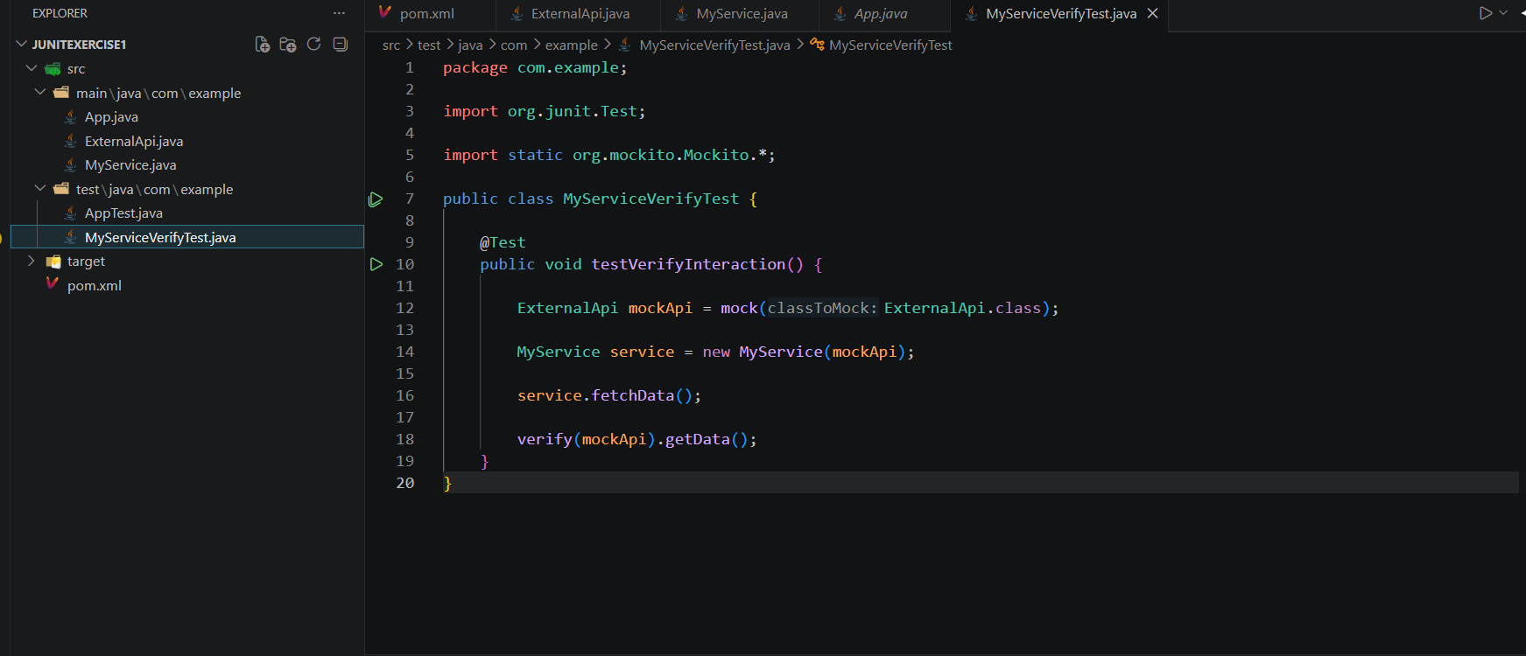

Step 4: Verify Interaction
Mockito's verify() method was used to confirm that getData() was called.
verify(mockApi).getData();

Step 5: Execute Test
The Maven test command was executed.
mvn test
Screenshot 5:
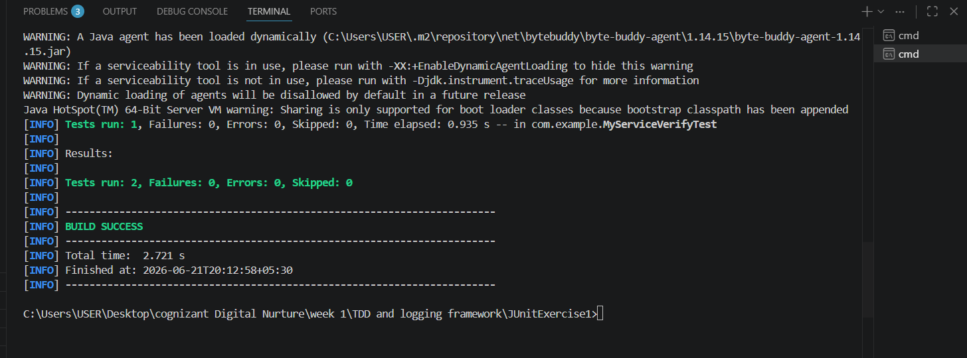

Output
The verification was successful and all test cases passed.
Tests run: 1
Failures: 0
Errors: 0
BUILD SUCCESS

Result
Mockito successfully verified that the getData() method was invoked on the mocked ExternalApi object.

Conclusion
This exercise demonstrated the use of Mockito's verification mechanism to confirm interactions between application components. Verifying method calls ensures that dependencies are being used correctly and improves the reliability of unit tests.

